
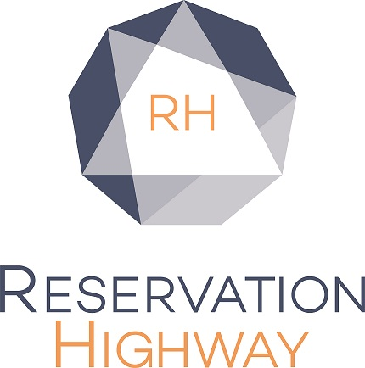

Annual Conference 3 – 5 June 2024 MANCHESTER CENTRAL

Reservation Highway has arranged specially negotiated rates at selected hotels.
EARLY BOOKING HIGHLY RECOMMENDED PLEASE BOOK BY: Friday 3rd May 2024

Bookings made after this date will be on a request basis and subject to availability, rates may vary.

Book on-line: www.reservation-highway.co.uk/bcs24

Telephone our helpdesk +44 (0) 1423 525577 Email to admin@reservation-highway.co.uk

_____
Please tick: Delegate Exhibitor Exhibition Visitor

Name (contact)……………………………………………………………………………………………………………………………..

Company Name……………………………………………………………………………………………………………………………

Address……………………………………………………………………………………………………………………………………..

Town…………………………………County…………………………………Country……………………….Post code…………..

Telephone………………………………………...………….Email………………………………………………………………………
Bookings are confirmed by email, please print clearly

Hotel 1st Choice

Hotel 2nd Choice

Guest names | Room type | No. of guests | Arrival date | No. of nights
Hotel 3rd Choice
NB: When there are no single rooms available a double or twin for single occupancy will be allocated automatically

Please indicate how you wish to secure your booking:

◻ Proforma invoice to be sent (payment to be made in full 21 days prior to arrival)

◻ Credit card guarantee (payment made to the hotel direct on departure)

Card type: (please circle) VISA MASTERCARD AMEX (Amex not accepted by all guesthouses)

Card No: -- -- -- -- / -- -- -- -- / -- -- -- -- / -- -- -- -- Expiry date: -- -- / -- --
Security digits may be required by some hotels to complete the transaction please give a contact telephone number below where the cardholder can be contacted.

Telephone……………………………………………………….

No charge is taken from this credit card by reservation highway. The card is used to guarantee your accommodation with the hotel. They may charge the card for non-arrival or late cancellation (cancellation policy for 9 rooms or less is 7 days prior to arrival unless otherwise stated on your confirmation.) All hotel accounts must be settled upon departure.

Reservation Highway Ltd, Wells House, 8 Cold Bath Road, Harrogate, HG2 0NA
Company Registration No: 04518087

