
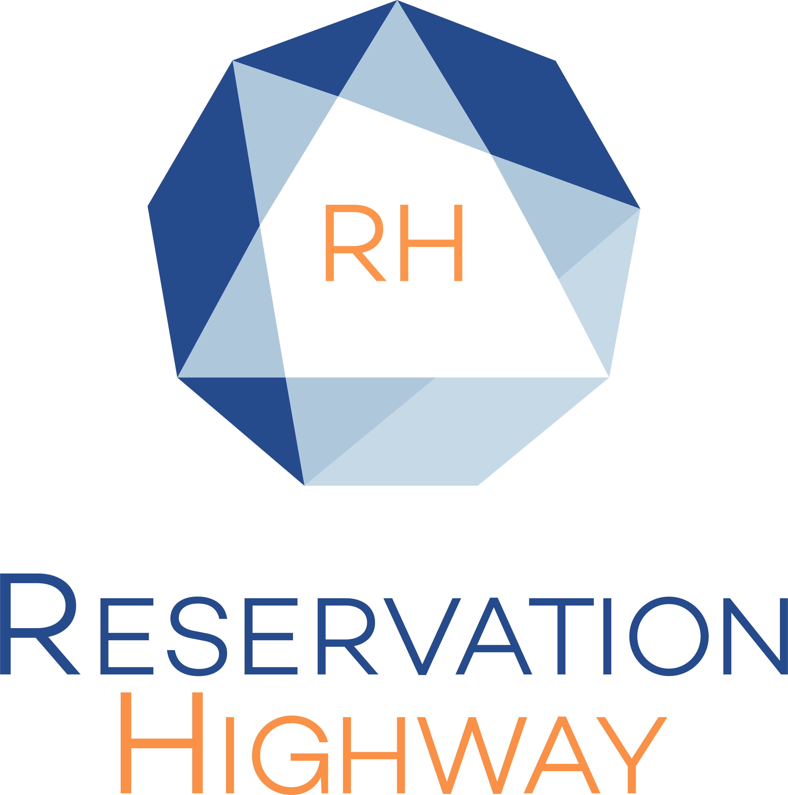

Annual Conference 6 – 8 June 2022 MANCHESTER CENTRAL

Reservation Highway has arranged specially negotiated rates at selected hotels.

EARLY BOOKING HIGHLY RECOMMENDED PLEASE BBOK BY: Friday 6th May 2022

Bookings made after this date will be on a request basis and subject to availability, rates may vary.

Book on-line: www.reservation-highway.co.uk/bcs22

Telephone our helpdesk +44 (0) 1423 525577

Email to admin@reservation-highway.co.uk

Hotel | Distance to Venue (mile) | Car Parking | Star  Rating | Terms | Double/Twin for sole use | Double/Twin
The Edwardian Manchester | 0.1 m | NCP | ***** | BB | £215 | £235
The Midland Manchester | 0.1 m | NCP | **** | BB | £150 | £160
DoubleTree by Hilton Manchester | 0.6 m | NCP | **** | BB | £140 | £153
Novotel Manchester | 0.2 m | NCP | **** | BB | £130 | £140
Mercure Manchester Piccadilly | 0.5 m | OSP | *** | BB | £125 | £135
Macdonald Manchester | 0.7 m | OSP | **** | BB | £120 | £130
Innside Manchester | 0.2 m | NCP | **** | BB | £120 | £125
Jurys Inn Manchester | 0.1 m | NCP | *** | BB | £100 | £110
Ibis Manchester Portland Street | 0.3 m | NCP | ** | BB | From  £90 | From  £95
The Pendulum Hotel | 0.5 m | NCP | *** | BB | £80 | £90
Ibis Manchester Princess Street | 0.5 m | NCP | ** | BB | From  £80 | From  £85

All rates are quoted per room per night and inclusive of VAT at the prevailing rate.
Terms are BB = Bed & Breakfast RO = Room Only
Car parking NCP = national car park OSP = on-site hotel parking.
Star ratings advertised by Reservation Highway follow the guidelines set out by VisitBritain and the AA.

Reservation Highway offer a full concierge service and can assist with travel advice to the event and other related services
to help you plan and enjoy your visit to Manchester.

RESERVATION HIGHWAY LIMITED WELLS HOUSE 8 COLD BATH ROAD
HARROGATE NORTH YORKSHIRE HG2 0NA
TEL: 01423 525577 EMAIL: admin@reservation-highway.co.uk
COMPANY REG NO: 04518087

