Application for Membership

Please submit this completed form to ukmcs@bcs.com.
Your annual membership fee is paid by Direct Debit once a year. Your membership will be processed following approval from the UKMCS Secretary.

Name
Job title and brief description of professional role

Professional address
Professional registration number (GMC etc)
Primary email address
Alternative email address
Telephone number
Alternative address for correspondence if preferred

Please tick as appropriate:

- Ordinary membership ☐ (£50)
(healthcare professionals actively involved in the care of women with cardiac disease in pregnancy or research in this field)

- Trainee membership ☐ (£30)
(for persons in training)

- Associated membership ☐ (£30)
(for persons from organisations and charities involved in the support of women and families affected by cardiac disease in pregnancy, as well as those involved in scientific study)
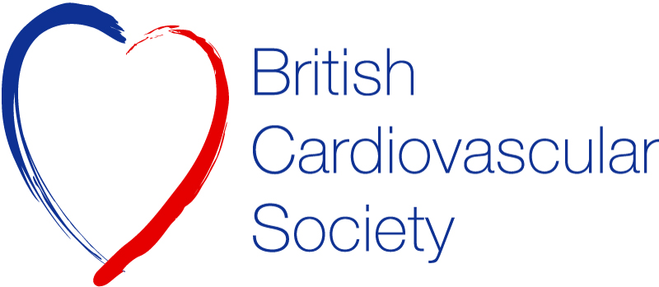

Instruction to your
Bank or Building Society
to pay by Direct Debit
Please fill in the whole form excluding official use box using a ball point pen and send it to: |  |  |  |  |  |  |  |  |  |  |  |  |  |  |  |  |  |  |  | Originator's Identification Number
British Cardiovascular Society  9 Fitzroy Square  London  W1T 5HW |  |  |  |  |  |  |  |  |  |  |  |  |  |  |  |  |  |  |  | 911994 | 1 | 1 | 9 | 9 | 4
FOR British Cardiovascular Society OFFICIAL USE ONLY
This is not part of the instruction to your Bank or Building Society.
Name(s) of Account Holder(s)
Bank/Building Society account number
Branch Sort Code |  |  |  |  |  |  |  |  |  |  |  |  |  |  |  |  |  |  |  | Instruction to your Bank or Building Society  Please pay British Cardiovascular Society Direct Debits from the account detailed in this Instruction subject to the safeguards assured by the Direct Debit Guarantee. I understand that this Instruction may remain with British Cardiovascular Society and, if so, details will be passed electronically to my Bank/Building Society.
Name and full postal address of your Bank or Building Society
To: The Manager |  |  |  |  |  |  |  |  | Bank/Building Society
Address |  |  |  |  |  |  |  |  |  |  |  |  |  |  |  |  |  |  |  | Signature(s)
 |  |  |  |  |  |  |  |  |  | Postcode |  |  |  |  |  |  |  |  |  | Date
Reference Number
U | K | M | C | S
Banks and Building Societies may not accept Direct Debit Instructions from some types of account
DDI1
.
This guarantee should be detached and retained by the Payer
The Direct Debit Guarantee
- This Guarantee is offered by all banks and building societies that accept instructions to pay Direct Debits.
- If there any changes to the amount, date or frequency of your Direct Debit, BCS will notify you 10 working days in advance of your account being debited or as otherwise agreed. If you request BCS to collect a payment, confirmation of the amount and date will be given to you at the time of the request.
- If an error is made in the payment of your Direct Debit by BCS or your bank or building society, you are entitled to a full and immediate refund of the amount paid from your bank or building society.
- If you receive a refund you are not entitled to, you must pay it back when BCS asks you to.
- You can cancel a Direct Debit at any time by simply contacting your bank or building society. Written confirmation may be required. Please also notify us.

