BCS Heritage Landing Page
History of the Society – From Cardiac Club to British Cardiovascular Society
The foundation of British cardiology began with Sir James Mackenzie (1853-1925), a Scot who graduated from the University of Edinburgh and subsequently became a general practitioner in Burnley. Mackenzie developed an interest in the pulse and his work attracted the attention of other physicians interested in heart disease. It was around 1910 that Mackenzie suggested this small group of like-minded physicians should form a club, but the First World War intervened. After the war, the government appointed consultants in all regions of Britain to give advice about pensions for people with war-related cardiac problems. The first meeting of the Cardiac Club was held in Oxford on Saturday, 22 April 1922.
To read more about the history of BCS:
History of the British Cardiovascular Society | Heart (bmj.com)

BCS Museum and Archive
The historical archive of the British Cardiovascular Society provides a unique insight into British cardiology and the development of our specialty. The collection was the brainchild of Dr Arthur Hollman (1923–2014), a former BCS secretary who bequeathed many items and promoted the importance of history and plants in medicine. He followed in the footsteps of Maurice Campbell and Evan Bedford, who had carefully ensured the story of the Society and specialty was maintained for future generations. The Arthur Hollman BCS Archive aims to acquire, organise and preserve material relating to members of the Society and British cardiology. Exhibited over several floors, the main rooms are named after pioneers of British cardiology: Mackenzie, Lewis and Wood.

IMAGE: There were 15 original members of The Cardiac Club; James Mackenzie was an honorary member.
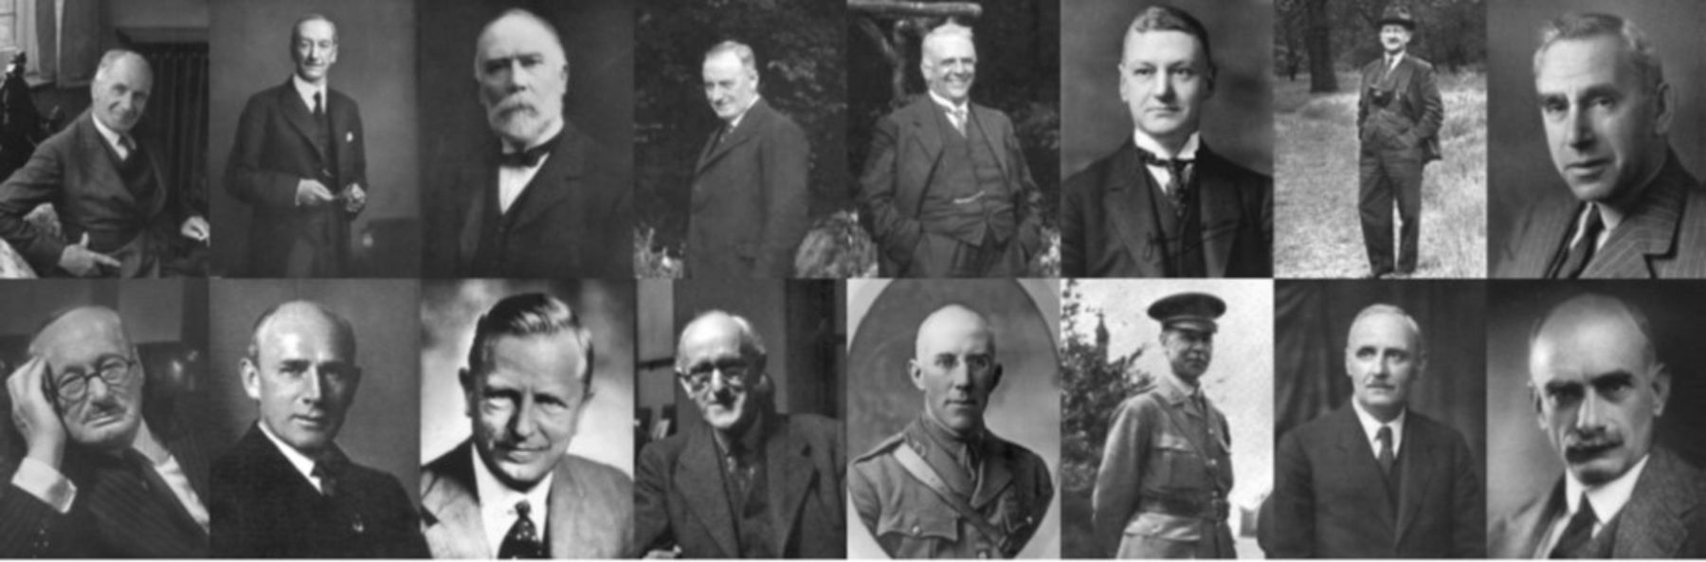

IMAGE: Important items include a) an early pericardial aspiration kit, b) a complete 1929 portable ECG made by the Cambridge Instrument Company and c) the original toy train used by Augustus Waller in 1887 to record the first human electrocardiogram.
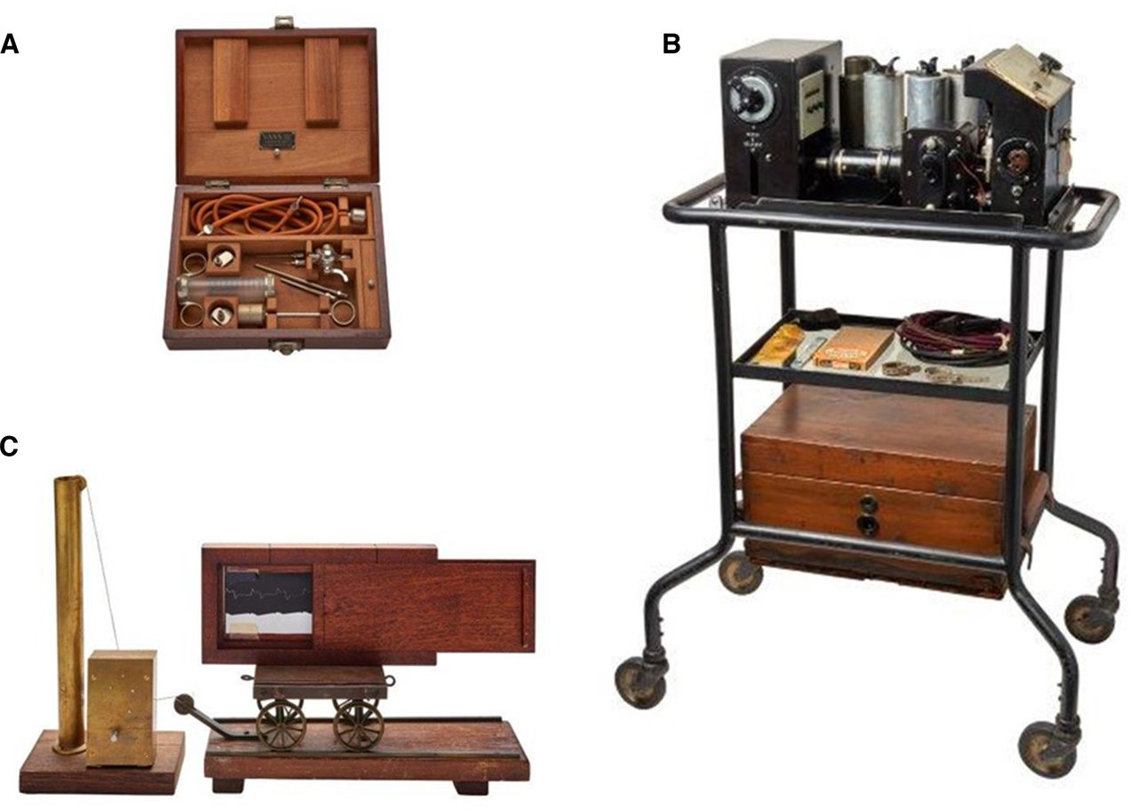

IMAGE: The BCS Museum, Library and Archive, 9 Fitzroy Square London
