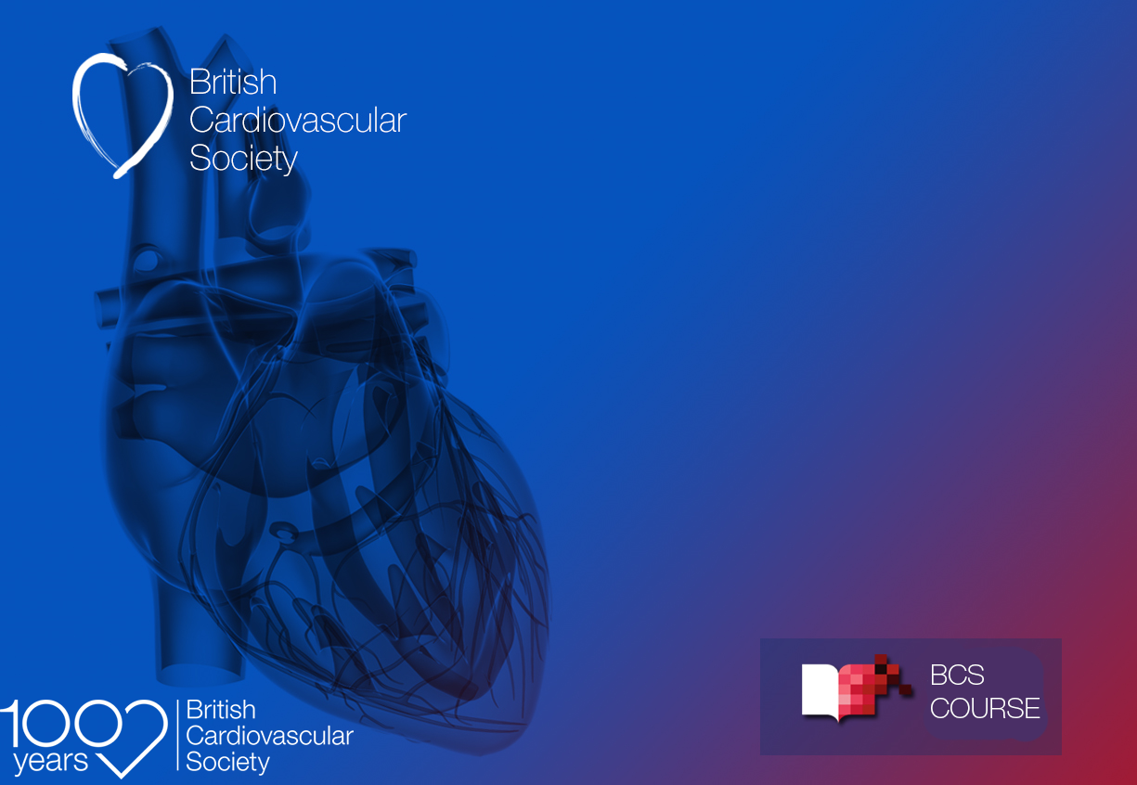
54£
Cardiology for Undergraduates
– a whistle stop tour
____________
AGENDA 2022

Cardiology for Undergraduates
– a whistle stop tour

Date: Wednesday 23 November 2022
Online: Pre-recorded presentations with Live Panel Discussion
____________________________________________________
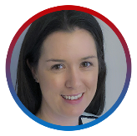
Course Directors

Dr Rebecca Dobson | Dr Shouvik Haldar
_________________________________________________

Gain an insight into cardiology with this showcase of cardiology sub-specialties. Aimed at medical students, the course provides the opportunity to learn about all of the different areas of cardiology, with talks on individual sub-specialties from Consultant Cardiologists and trainees. Tips on applying for cardiology training will also be covered. Live question and answer sessions throughout the event.

Certificate of Attendance
A certificate of attendance (in the name of the participant) will be made available once viewing of this online lecture has been finished, the delegate feedback survey completed and attendance validated. Certificate of attendance will only be available to those who have pre-registered for this event and attend the full webinar.

_________________________________________________________
Connect

#CFU2022
Contact
courses@bcs.com
or call us on
+44 (0)20 7380 1914

AGENDA

Session 1
13:00 – 13:10 Introduction
Dr Rebecca Dobson & Dr Shouvik Haldar

13:10 – 13:20 How cardiology training works
Dr Mark Westwood

13:20 -13:40 Interventional Cardiology
Dr Shazia Hussain

13:40-13:50 Electrophysiology
Dr Vishal Luther

13:50 – 14:05 Panel Q&A

14:05 – 14:15 Break

Session 2
14:15 – 14:25 Devices
Dr Jenny Llewelyn

14:25 – 14:35 Imaging
Dr Manish Motwani

14:35 – 14:45 Heart Failure
Dr Kaushik Guha.

14:45 – 14:55 Panel Q&A

14:55 – 15:05 Break

Session 3
15:05 – 15:15 Adult Congenital Heart Disease
Dr Sarah Bowater

15:15 – 15:25 Inherited Cardiac conditions and Sports Cardiology
tbc

15:25 – 15:35 Cardio-Oncology
Dr Alex Lyon

15:35 – 15:45 Community Cardiology
Dr Clare Hammond

15:45 – 15:55 Panel Q&A

15:55 – 16:00 Break

Session 4
16:00 – 16:10 Academic Cardiology
Dr Anvesha Singh

16:10 – 16:20 Flexible working in Cardiology
Dr Ayisha Khan-Kheil

16:20 – 16:30 How to get into Cardiology
Dr Will Jenner

16:30 – 16:45 Panel Q&A

16:45 – 16:50 Closing Comments

