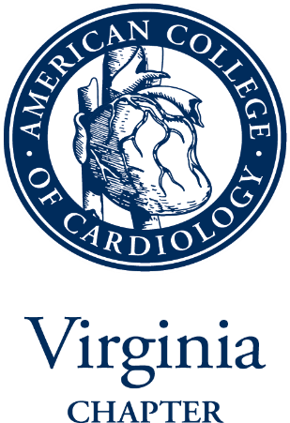
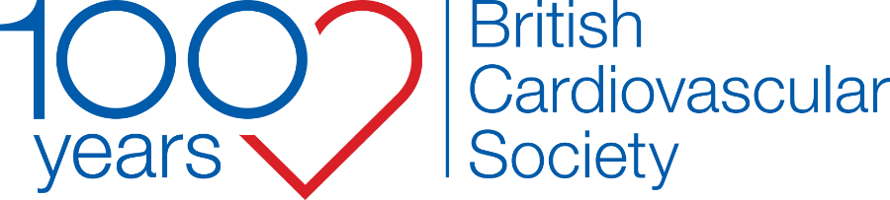

Centennial Ambassador Program in Honor of the British Cardiovascular Societies’ 100th Year

INTRODUCTION AND APPLICATION FORM
The Virginia Chapter of the American College of Cardiology (VCACC) and the British Cardiovascular Society (BCS) are a part of the American College of Cardiology’s International Exchange program. The BCS-VCACC relationship was formed through a desire of both organisations to develop long-term relationships between cardiovascular professionals in the United States and the United Kingdom. The partnership brings members from both nations together to learn about advances in CV science and exchange ideas on quality programming and health systems. Both societies aim to develop a portfolio to include educational programs, leadership courses, preceptorships, visiting lectures, etc. on both sides of the Atlantic.

FELLOWSHIP DETAILS
In honor of the BCS' 100th Anniversary the VCACC has created a program called the Centennial Ambassadors. This program will support four current trainees or early career cardiologists from the UK (out of training for less than seven years) who will visit, learn, and experience the American healthcare landscape, an imaging rotation (MRI, CT and Echo), and our CV community.

It is our aim in supporting the Centennial Ambassadors that we further strengthen our educational exchange in the greater cardiology community and forge even stronger bonds of friendship within the newest generation of cardiologists.

SCHEDULE
November 13 Depart UK Arrive in Charlottesville, VA
November 14 Rotation in Imaging at University of Virginia
November 15 Rotation in Imaging at University of Virginia
November 16 Travel to Washington, DC (most likely via train)
November 17 Rotation in Imaging at TBD
November 18 Rotation in Imaging at TBD
November 19 Opening Cocktail Reception for MACCS, Heart House, 5:30-7:00pm
November 20 Mid-Atlantic Capitol Cardiology Symposium (MACCS), 8:00am-3:00pm

SELECTION CRITERIA
Applications will be accepted from senior cardiology trainees or early career cardiologists (see above) who are sub-specialising in cardiac imaging and are fully paid-up ordinary members or joint members of the BCS. The applications will be judged by the senior leadership of the BCS and four successful candidates will be selected.

APPLICATION DEADLINE: 23rd September 2022
Winners will be announced week commencing 26th September 2022

Application Form

Applicant Name/title

Current post & hospital
Year of Training
E-mail Address:

Mobile Number:

BCS Membership number:

Please note that applicants must be a fully paid up ordinary member or joint member of the British Cardiovascular Society

1. Describe your current skills, experience and competencies relevant to the Centennial Ambassadors programme (max. 300 words)
2. Describe your specific learning needs and objectives from this programme (300 words)
3. Describe how you plan to consolidate and implement the knowledge gained for your patients (300 words)

4. Please provide any further information to support your application (300 words)
Please note: obtaining the relevant visas/travel permits for entry into the US can take time and should be considered in advance before applying. It is the responsibility of the applicant to make all necessary travel arrangements and insurance cover for US entry and return to UK.

Please save your completed application as a single PDF document and send to executivepa@bcs.com no later than 23rd September 2022

I confirm that all of the details above are correct and that I have organisational approval for study leave for the period covered by the Centennial Ambassador Program.

Should I be awarded a place on the Centennial Ambassador Program, I will send a final written report to BCS head office not later than one month after the return date. This will be a maximum of 600 words outlining the benefits of the Centennial Ambassador Program to your training and future cardiology career.

I agree that BCS may process my personal data in the course of the evaluation of my application and consent to publishing my name as participant of the Centennial Ambassador Program, either electronically or in print format.

In processing this Application, BCS shall observe and comply with all applicable current and future data privacy and security laws, including without limitation the General Data Protection Regulation (“GDPR”). BCS further represents and warrants that: (i) any personal data processed will only be processed for the review of this Application; (ii) BCS will maintain effective information security measures to protect personal data from unauthorized disclosure or use; (iii) BCS will delete or return all personal data at the applicant’s request and upon termination of the Agreement; and (iv) if the consultants, employees or agents of BCS have access to the personal data under the terms of this Application, BCS will ensure such persons with access to the personal data will keep it confidential.

AUTHORISATION:

APPLICANT NAME:

SIGNATURE:

DATE:

ORGANISATION APPROVAL

NAME (CLINICAL DIRECTOR of employer):

SIGNATURE:

DATE:

ORGANISATION NAME:

Further Information:

FLIGHTS
Please plan to fly all the way to Charlottesville, VA on the inbound flight. Make the departure flight from a Washington, DC area airport. Note that the connection time from a US gateway airport to the Charlottesville flight should be at least two hours. Incoming members must clear customs and immigration at gateway airport. First departure to the UK would be a later evening flight on November 20 (after 8pm). Note that travel time to Dulles airport is one hour and the suggested time to arrive for international flights is three hours prior to departure.

November 18 onwards is a very busy time in US airports due to the Thanksgiving holiday. If the BCS members want to extend their stay (at their own expense) for leisure activities, it is highly recommended not to travel on any mode of transportation (car, train, airplane) on November 23rd or 27th. These are the busiest days of the year for all US roads, train routes, and airports.

LODGING
Lodging in Charlottesville will be at a private residence; in Washington, DC lodging will be at the Marriott Georgetown.

LOCAL TRAVEL
VCACC members will arrange, where needed, to have car pick-ups from lodging to hospitals.

REIMBURSMENT
Flights in coach/economy and related travel costs (parking, train) will be reimbursed by VCACC. VCACC will make the hotel arrangements in Washington, DC at the headquarters hotel, room and tax will be put on the master account for the nights of November 16 - 20. VCACC will also register members for the MACCS conference. Meals and incidentals are not included, however, VCACC members will be arranging to host BCS members for many meals.

