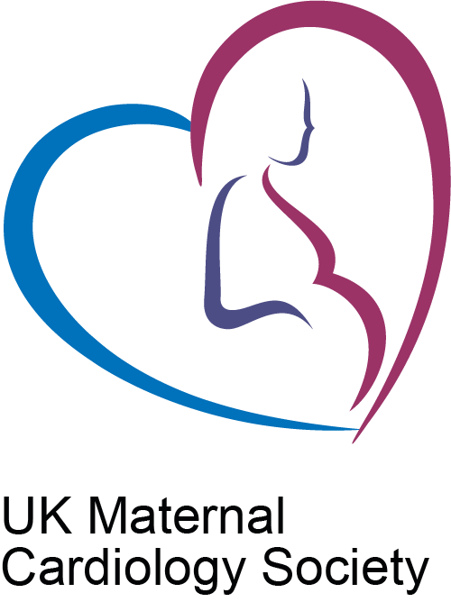

UK Maternal Cardiology Society Annual Meeting
Venue: thestudio Birmingham https://thestudio.co.uk/venues/birmingham/
Tuesday 21st November 2023
Register here
UKMCS members £75 consultant and £20 doctors in training, nurses and midwives.
Non-members £125 consultant and £50 doctors in training, nurses and midwives.
To join UKMCS
Programme:
09.00 - 10.00 Annual General Meeting for UKMCS members only- This part of the meeting is free to attend, but members may only stay for the subsequent eucational meeting if they have registered in advance
10.00 - 10.10 Welcome and Introduction to UKMCS Educational meeting
Dr Dawn Adamson, President UKMCS
10.10- 11.30 Session 1: Lessons learned in heart disease in pregnancy:
Chair: Dawn Adamson, Cardiologist, Warwick
10.10. 10.30 Update from MBRRACE
Dr Cathy Head, Cardiologist, Norwich
10.30 - 11.05 Screening for heart disease at booking- what questions should be asked?
Dr Hannah Douglas, Cardiologist, London
Sharon Elder, Midwife, London
11.05 - 11.30 Coffee Break

11.30 – 13.10 Session 2: Pre-pregnancy counselling in heart disease:
Chair: Johanna Trinder, Obstetrician, Bristol
General introduction to PPC from:
11:30-11:50 Cardiologist perspective : Victoria North, Cardiologist, Bristol
11:50-12:10 Obstetric perspective : Mandish Dhanjal, Obstetrician, London

Pre-pregnancy counselling – special considerations in :
12:10-12:25 1. Aortopathy
Stephanie Curtis, Cardiologist, Bristol
12:25-12:40 2. Cardiomyopathy
Alex Simms, Cardiologist, Leeds
12:40-12:55 3. Ischaemic heart disease
Dawn Adamson, Cardiologist, Coventry
12:55- 13.10 Questions
13:10-14:00 Lunch

14.00- 15.20 Session 3:Management of cardiac conditions in pregnancy:
Chair: Kate English, Cardiologist, Leeds
14:00-14:40 Anticoagulation in the cardiac patient- How, why, whether to anticoagulate in pregnancy
Dr Will Lester, Haematologist, Birmingham
Anita Banerjee, Obstetric Physician, London
14.40-15:00 Acute management of cardiac arrythmias during pregnancy
Bode Ensam, Cardiologist, Birmingham
15:00- 15:20 Management of Long QT / Brugada
Dr Rachel Myles, Cardiologist, Glasgow

15.20 – 15.45 Tea
15.45 – 16:55 Session 4: Complex cases for the experts:
Chair: Anita Banerjee, Obstetric Physician, London
Complex cases in pregnancy cardiology
Panel:
Cardiologists: Dr Kate English and Dr Steph Curtis
Anaesthetist: Dr Kailash Bhatia, Manchester and Dr James Geoghegan, Birmingham
Obstetricians: Dr Mandish Dhanjal, London and Dr Matt Caudwell, London
Obsetric physician: Dr Charlotte Frise, London
Midwives: Sharon Elder, London and Claire Hendry, Coventry

16.55 - 17.00 Summing up and Finish
Dr Dawn Adamson, President UKMCS

